Lab[15-02-24]

Binary tree

#include <stdio.h>  
#include <stdlib.h>  
struct TreeNode {  
    int data;  
    struct TreeNode\* left;  
    struct TreeNode\* right;  
};  
struct TreeNode\* createNode(int data) {  
    struct TreeNode\* newNode = (struct TreeNode\*)malloc(sizeof(struct TreeNode));  
    newNode->data = data;  
    newNode->left = newNode->right = NULL;  
    return newNode;  
}  
struct TreeNode\* insertNode(struct TreeNode\* root, int data) {  
    if (root == NULL) {  
        return createNode(data);  
    }  
    if (data < root->data) {  
        root->left = insertNode(root->left, data);  
    } else if (data > root->data) {  
        root->right = insertNode(root->right, data);  
    }  
    return root;  
}  
void inOrderTraversal(struct TreeNode\* root) {  
    if (root != NULL) {  
        inOrderTraversal(root->left);  
        printf("%d ", root->data);  
        inOrderTraversal(root->right);  
    }  
}  
void preOrderTraversal(struct TreeNode\* root) {  
    if (root != NULL) {  
        printf("%d ", root->data);  
        preOrderTraversal(root->left);  
        preOrderTraversal(root->right);  
    }  
}  
void postOrderTraversal(struct TreeNode\* root) {  
    if (root != NULL) {  
        postOrderTraversal(root->left);  
        postOrderTraversal(root->right);  
        printf("%d ", root->data);  
    }  
}  
void displayTree(struct TreeNode\* root) {  
    printf("In-order traversal: ");  
    inOrderTraversal(root);  
    printf("\n");  
    printf("Pre-order traversal: ");  
    preOrderTraversal(root);  
    printf("\n");  
    printf("Post-order traversal: ");  
    postOrderTraversal(root);  
    printf("\n");  
}  
int main() {  
    struct TreeNode\* root = NULL;  
    int choice, data;  
    do {  
        printf("1. Insert a node\n");  
        printf("2. Display tree\n");  
        printf("3. Exit\n");  
        printf("Enter your choice: ");  
        scanf("%d", &choice);  
        switch (choice) {  
            case 1:  
                printf("Enter data to insert: ");  
                scanf("%d", &data);  
                root = insertNode(root, data);  
                break;  
            case 2:  
                if (root == NULL) {  
                    printf("Tree is empty.\n");  
                } else {  
                    displayTree(root);  
                }  
                break;  
            case 3:  
                printf("Exiting program.\n");  
                break;  
            default:  
                printf("Invalid choice. Please try again.\n");  
        }  
    } while (choice != 3);  
    return 0;  
}

ouput :-

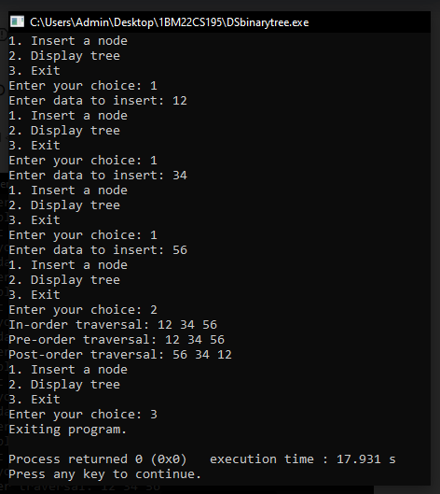

Leet code:-

struct ListNode\* rotateRight(struct ListNode\* head, int k) {

if (head == NULL || k == 0) {

return head;

}

struct ListNode\* current = head;

int length = 1;

while (current->next != NULL) {

current = current->next;

length++;

}

k = k % length;

if (k == 0) {

return head;

}

current = head;

for (int i = 1; i < length - k; i++) {

current = current->next;

}

struct ListNode\* newHead = current->next;

current->next = NULL;

current = newHead;

while (current->next != NULL) {

current = current->next;

}

current->next = head;

return newHead;

}

Output:-

